# National University of Computer and Emerging Sciences



**Lab Manual # 12**

**Digital Logic Design**

**(EL1005)**

|  |  |
| --- | --- |
| Course Instructor | Ms. Nazish Saleem |
| Lab Instructor(s) | Ms. Fareeha Ashfaq |
| Section | BDS-2B |
| Semester | Spring 2022 |

Department of Computer Science

FAST-NU, Lahore, Pakistan

**Objectives:**

Understanding of

* Registers
* Counters
* Sequential Circuits

# D Flip Flops:

IC code 🡪

**IC configuration:**

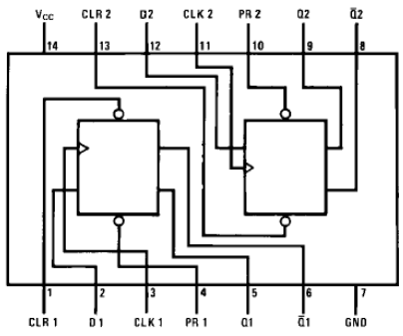

**Truth Table:**

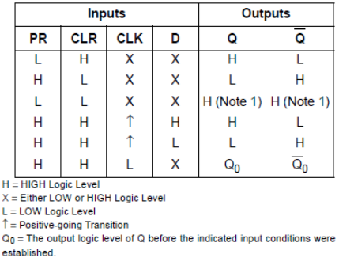

# JK Flip Flops:

IC code 🡪**DM74LS76A**

**IC configuration:**

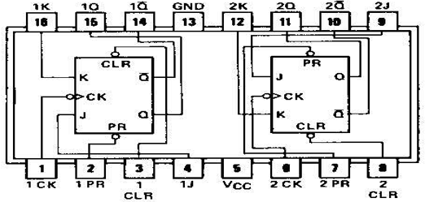

**Truth Table:**

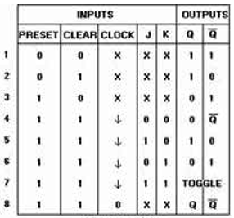

**Lab Tasks**

**Question 1:**

Design and implement a sequential logic circuit that detects the sequence “101”.

**Question 2:**

Design and implement 3-bit synchronous up counter Circuit on Logic Work using JK flip flop.

**Question 3:**

Design and implement 4-bit asynchronous down counter Circuit on Logic Work using D flip flop.